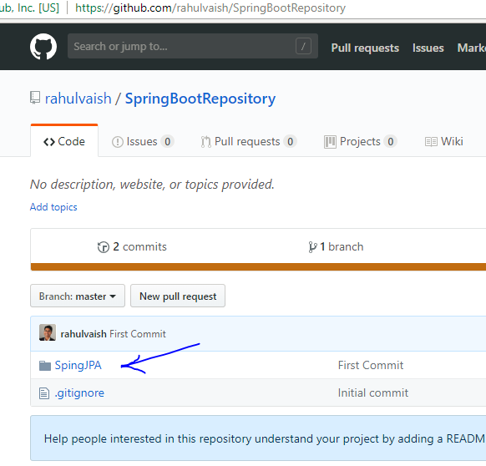

Right click on any folder🡪 Git clone

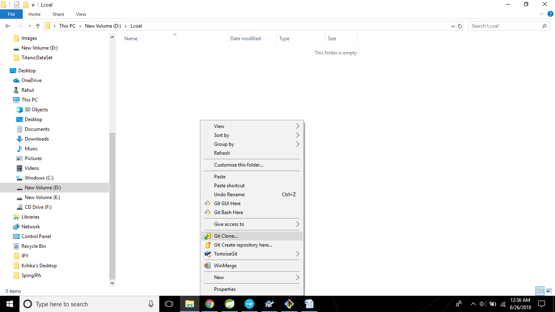

Paste the Git URI

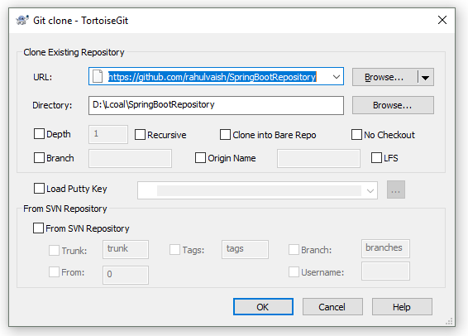

Click on OK , and cloning happens successfully.

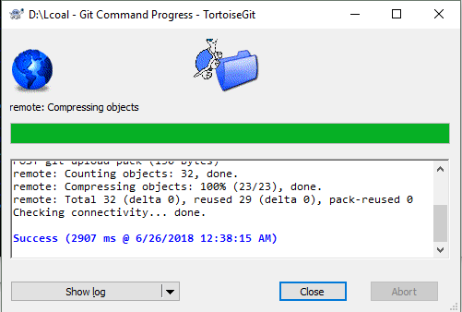

**Till now, you have successfully cloned the repository. As you want to work on a specific project that would be residing on a particular branch, what needs to be done is R/C-> Switch Checkout-> select your desired branch->OK**

Now the folder you chose for Git Clonning, make the same folder as your eclipse workspace.

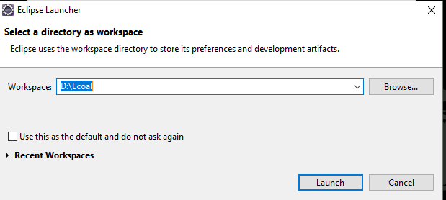

Import the project from the same folder.

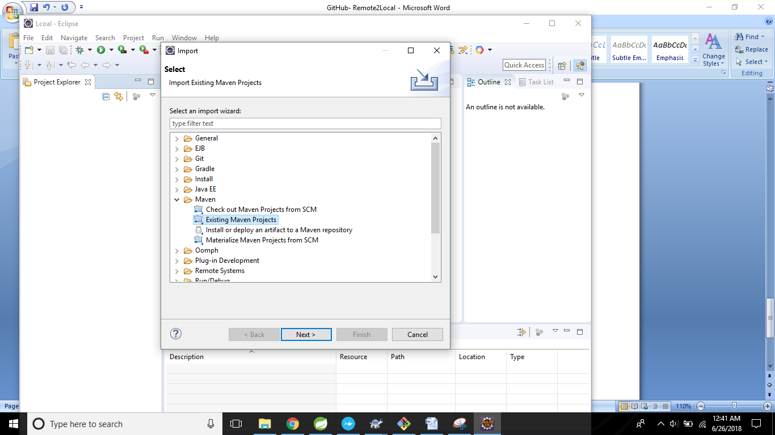

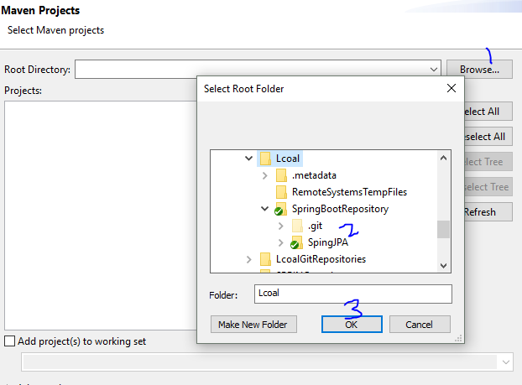

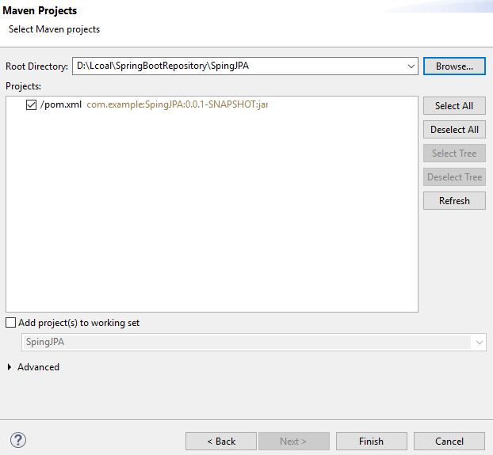

Things look good ☺

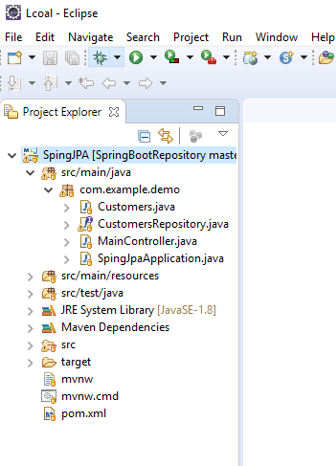

Now, Right click on the project -> RunAs-> Maven build-> write clean install in goals and maven process starts. The process ends with success. And you are ready to Run ☺